**Introduction**

Wine has been a staple in human culture for thousands of years, with its quality often associated with complex sensory experiences, traditions, and precise production techniques. In recent years, the wine industry has increasingly turned to data science and machine learning to better understand and predict wine quality, improve production processes, and meet consumer preferences. One such initiative involves analyzing the Wine Quality Dataset, a rich source of information containing various physicochemical properties of red and white wine samples along with corresponding quality ratings. This project aims to perform a comprehensive exploratory data analysis (EDA) of the Wine Quality Dataset using Python to extract meaningful insights and identify the factors that influence wine quality.

Exploratory Data Analysis (EDA) is a critical step in any data-driven project. It allows data scientists and analysts to delve into the dataset, identify patterns, detect anomalies, test hypotheses, and check assumptions. By employing various statistical techniques and data visualization tools, EDA helps in transforming raw data into an understandable structure. In the context of wine production, EDA can uncover how different chemical attributes—such as acidity, sugar content, sulfur levels, alcohol percentage, and more—relate to the perceived quality of wine, as rated by professional tasters.

The Wine Quality Dataset, which forms the foundation of this project, contains data on multiple chemical features (like pH, citric acid, residual sugar, chlorides, and others) derived from physicochemical tests. Each wine sample is also associated with a quality score, typically ranging from 0 to 10. These scores provide a target variable that can be analyzed against the other features to determine what constitutes a high-quality wine. Understanding this relationship is not only of academic interest but also of significant practical value for vintners, producers, and distributors who aim to maintain or improve their product standards.

In this project, Python has been chosen as the primary tool for data analysis due to its powerful libraries such as pandas, NumPy, matplotlib, and seaborn, which facilitate efficient data manipulation and visualization. The analysis begins with loading and inspecting the dataset to understand its structure, dimensions, and types of variables involved. Data cleaning is performed where necessary to handle missing values, outliers, or inconsistencies. This step ensures that the analysis is built upon accurate and reliable data.

Subsequently, the project focuses on computing measures of central tendency (mean, median, and mode) and dispersion (standard deviation, variance) for each attribute. These metrics provide a summary of the data’s distribution and variability. Visualizations such as histograms, box plots, correlation heatmaps, and pair plots are employed to explore the relationships between different variables and detect any trends or correlations with wine quality. Special attention is given to variables that show strong positive or negative correlations with quality ratings, such as alcohol content, volatile acidity, and sulphates.

The insights derived from this EDA can have practical applications in the wine industry. For example, identifying the chemical properties most closely linked to high-quality wine can help producers fine-tune their fermentation processes or adjust ingredient levels to enhance taste and quality. Moreover, the analysis lays a solid groundwork for building predictive models using machine learning techniques, which can automate the assessment of wine quality and reduce reliance on subjective human judgment.

In conclusion, this project provides a detailed exploratory analysis of the Wine Quality Dataset, revealing patterns and relationships that contribute to the overall quality of wine. By combining statistical analysis and visualization, it not only enhances understanding of the dataset but also offers valuable insights for quality control and production optimization in the wine industry. The findings from this project can ultimately aid in developing data-driven strategies for producing consistently high-quality wines.

**Objective**

The primary objective of this analysis is to:

* Explore the distribution and relationships of various physicochemical properties of white wine samples.
* Derive statistical summaries to represent the dataset concisely.
* Draw meaningful conclusions about the features contributing to wine quality.

The primary objective of this analysis is to gain a comprehensive understanding of the physicochemical properties of white wine samples and to explore how these properties relate to the overall quality of the wine. Wine quality is a multifaceted concept influenced by various chemical and sensory attributes, and understanding the underlying factors that contribute to it is essential for wine producers, quality control experts, and consumers alike. This study focuses on extracting meaningful insights from a dataset that includes several physicochemical measurements of white wine samples, such as acidity, sugar content, pH level, alcohol concentration, and more.

The first goal of the analysis is to examine the distribution of each variable in the dataset. This involves identifying the central tendencies, such as mean and median, as well as the spread, including variance, standard deviation, and range. Understanding how these variables are distributed helps in detecting any anomalies, outliers, or skewed data, which can significantly impact further analysis and model accuracy. Visual tools like histograms, box plots, and density plots will be employed to provide a clear picture of how each feature behaves across the dataset.

The second goal is to explore the relationships between these features. This will be achieved by using statistical correlation matrices and visualizations such as scatter plots and heatmaps to identify linear or non-linear associations between variables. For example, investigating how alcohol content correlates with wine quality or whether pH levels influence the perception of taste could uncover critical patterns. By identifying strong correlations, we can better understand which physicochemical factors are most influential in determining wine quality.

Furthermore, this analysis aims to provide concise statistical summaries that encapsulate the key characteristics of the dataset. These summaries will serve as a foundation for both exploratory data analysis and subsequent modeling efforts. Descriptive statistics and inferential methods will be used to generalize findings and support data-driven conclusions.

Ultimately, the analysis aspires to draw meaningful conclusions about the features that most significantly contribute to the quality rating of white wine. By doing so, the study will not only offer insights into the factors that define high-quality wine but also provide a reference point for future studies in wine classification, quality prediction, and optimization of production processes. This objective aligns with the broader goal of leveraging data science to enhance understanding and decision-making in the wine industry.

**Tools and Technologies Used**

* **Programming Language**: Python
* **Libraries**:
  + pandas: for data manipulation
  + numpy: for numerical operations
  + matplotlib and seaborn: for data visualization

**Dataset Description**

The dataset used in this analysis is the **Wine Quality Dataset**, specifically focusing on **white wine**. It consists of **4,898 rows and 12 columns**. Each row represents a wine sample, and each column describes a physicochemical attribute or the quality score.

**Features Included:**

1. Fixed Acidity
2. Volatile Acidity
3. Citric Acid
4. Residual Sugar
5. Chlorides
6. Free Sulfur Dioxide
7. Total Sulfur Dioxide
8. Density
9. pH
10. Sulphates
11. Alcohol
12. Quality (Score between 0 and 10)

Data source: Kaggal.com

**Data Loading and Exploration**

The dataset is loaded using pandas.read_csv() and initially explored using .head(), .info(), .columns, and .shape functions.

**Key Findings:**

* There are **4898 observations**.
* The dataset does **not contain missing values**.
* All features are **numerical**.

**Project Section – Coding and Output**

**1.**

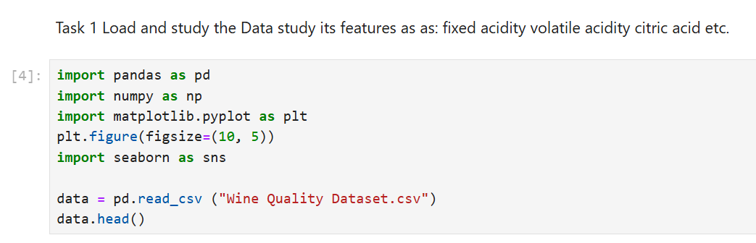

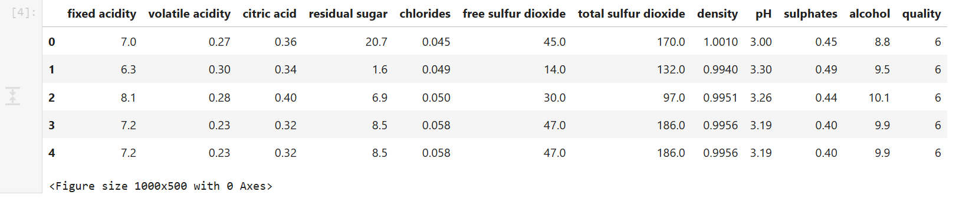Output-

2.

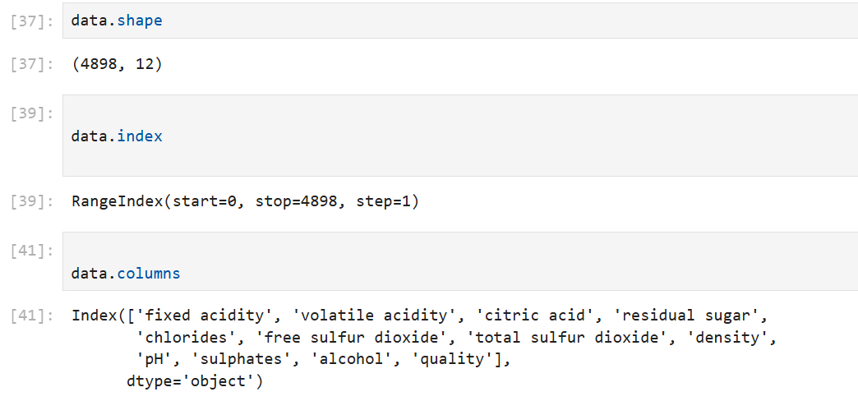

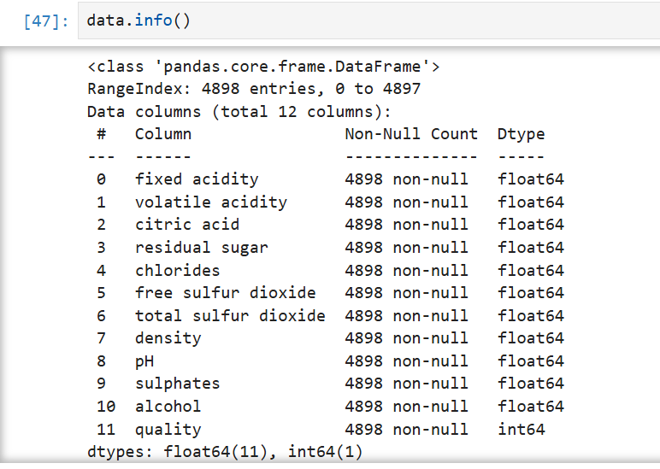3.

**Observations From Task 1**

There are 4898 row and 12 colunm in the data. each row contains the details of the types of acids present in white- wine

and the quality.

The feature in the data set are: Diffrent acid and their quality.

___________________________________________________________________________

**Task 2** - View the distributions of the various features in the data set and calculate their central tendencies We will now look at the distributions of the various features in the data set We will also calculate appropriate measures of central tendency for these features.

4.

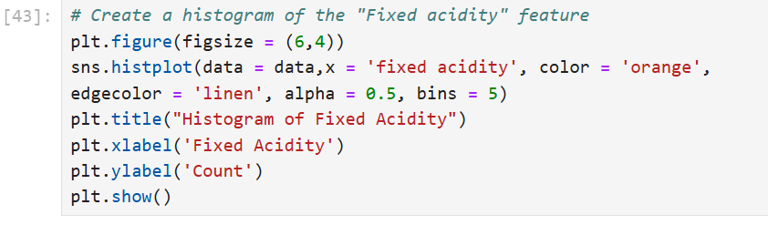

Output-

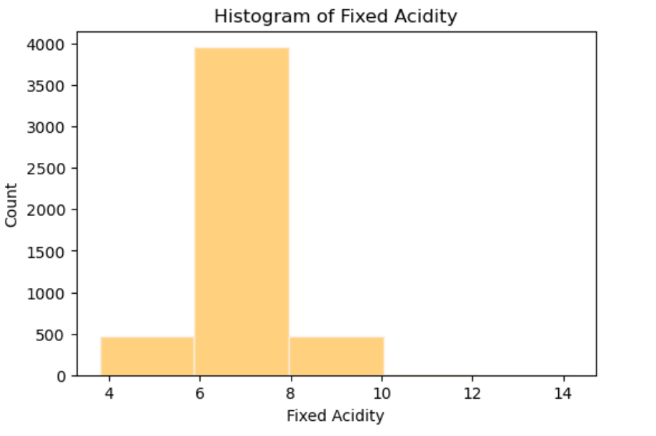

Observations- We observe that the histogram is normally distributed. The maximum count of values for fixed acidity lies in between 6 to 8. Let's see the measures of central tendency in working!

1. Mean
2. Median
3. Mode

5.

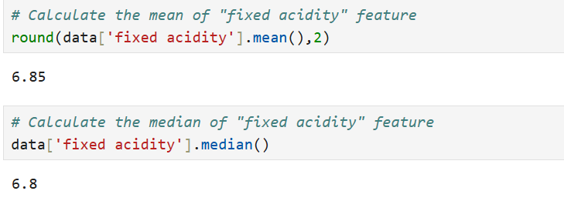

Calculate mean and median of “fixed acidity”

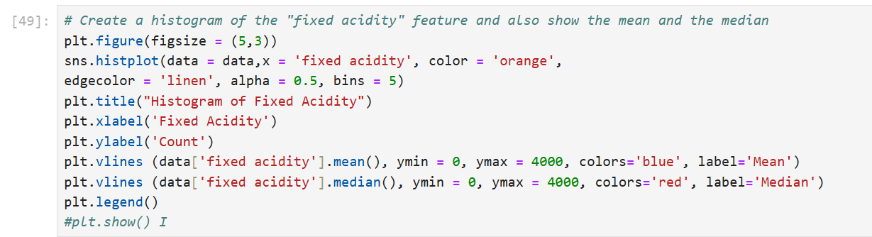6.

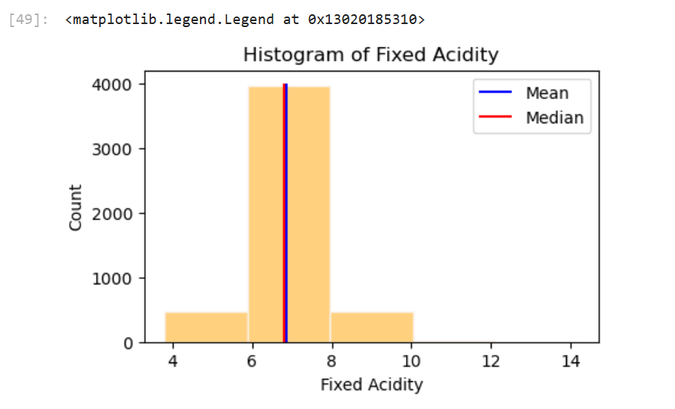Output-

**Observations-** We can see that mean and median are clear representative of the data. Mean and median are very close to each other. We can choose either of the parameters say mean as the measure of central tendency.

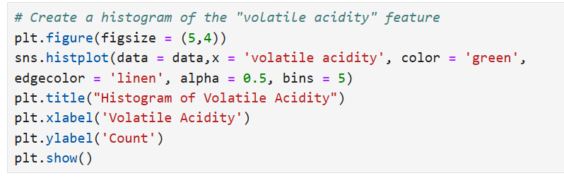7.

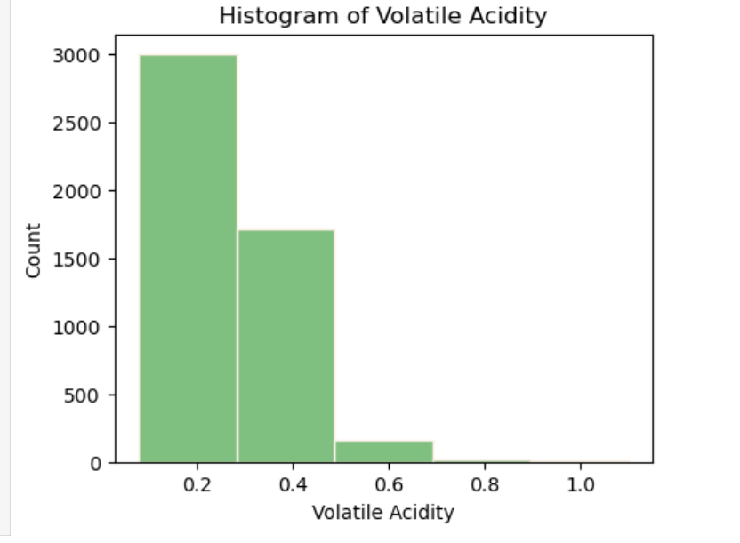Output-

**Observations**- We observe that this histogram is not well distributed, it is skewed a little towards the right. As we have seen skewness, therefore we can check the distribution using distplot function.

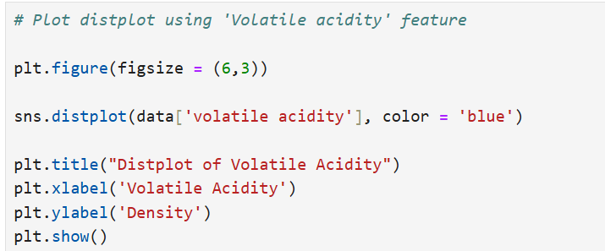8.

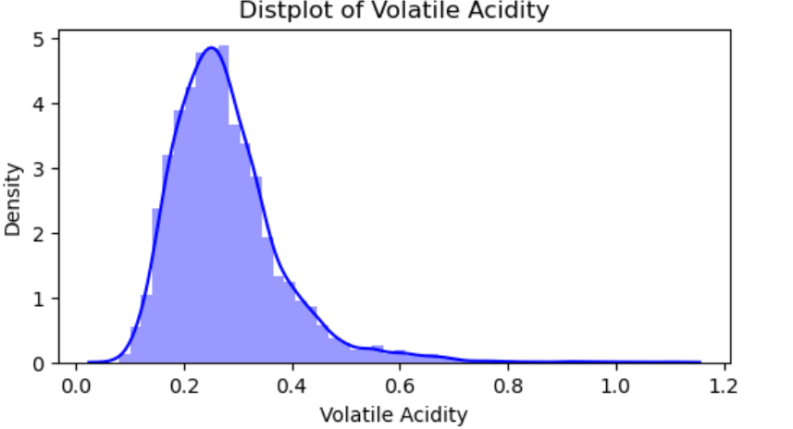Output-

**Observation:** The above plot shows the normal distribution. The normal distribution is described by the mean and the standard deviation. The normal distribution is often referred to as a 'bell curve' because of it's shape:

• The median and mean are equal

• It has only one mode

• It is symmetric, meaning it decreases the same amount on the left and the right of the centre.

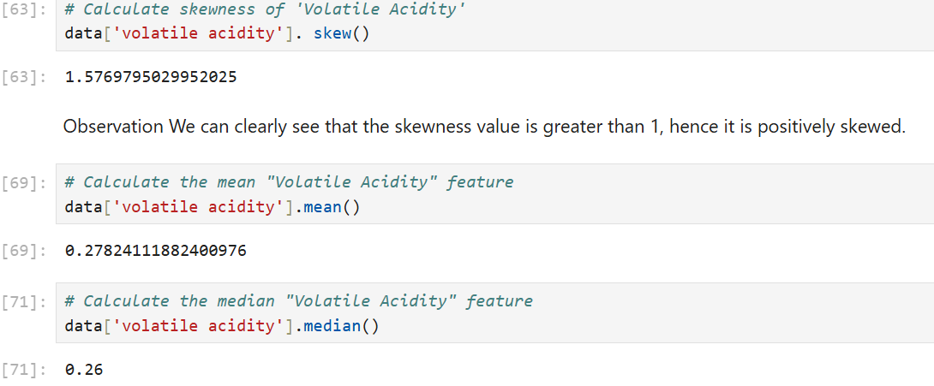9.

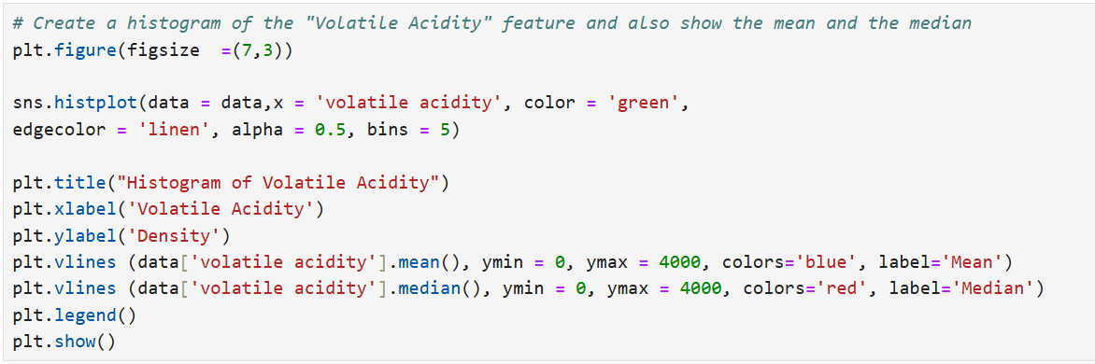10.

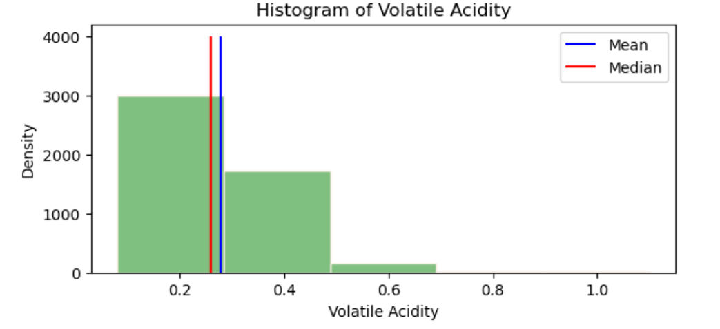Output-

**Observations**- The mean and the median are close to each other and the difference between them is very small. We can safely choose the mean as the measure of the central tendency here.

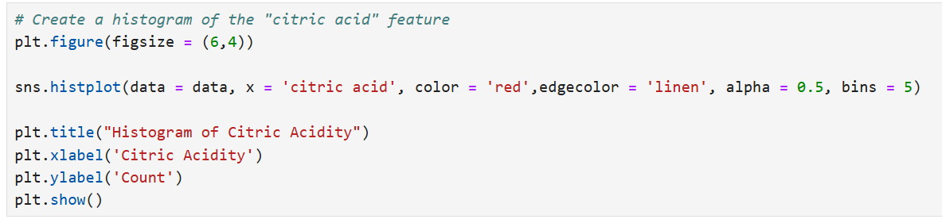11.

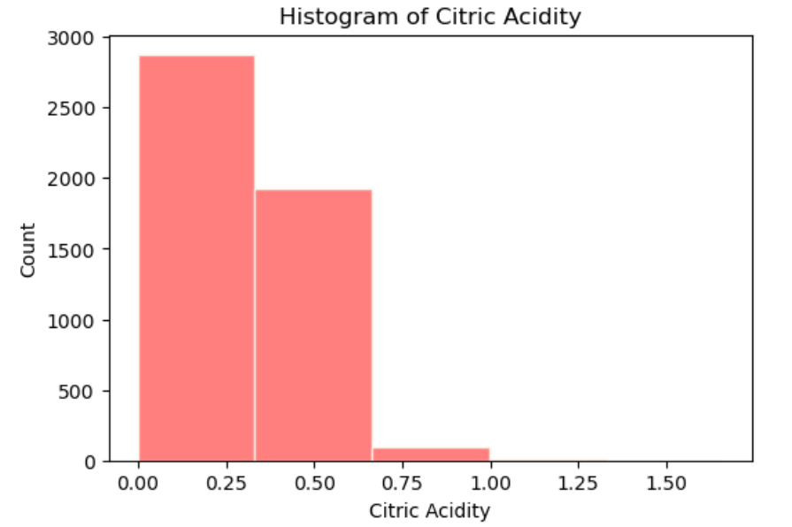Output-

We observe that this histogram is not well distributed, it is skewed a little towards the right.

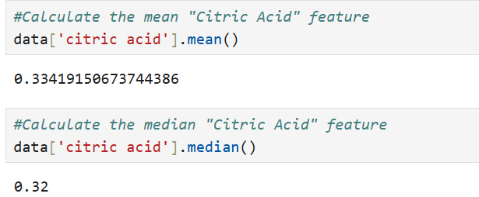12.

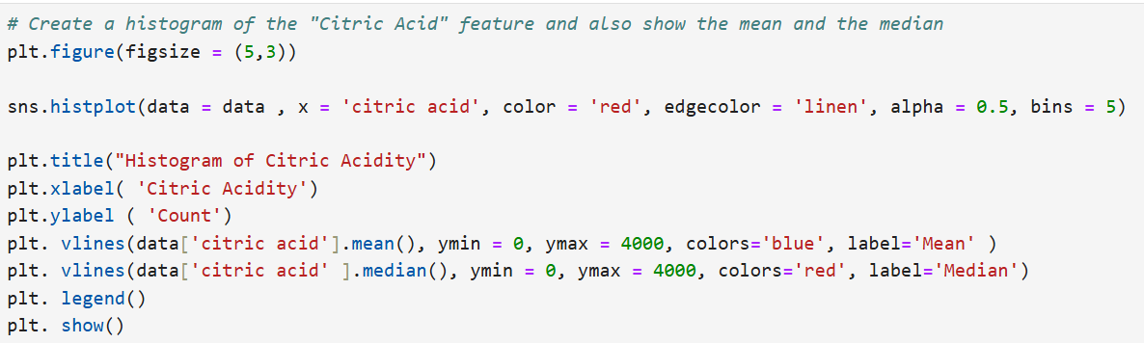13.

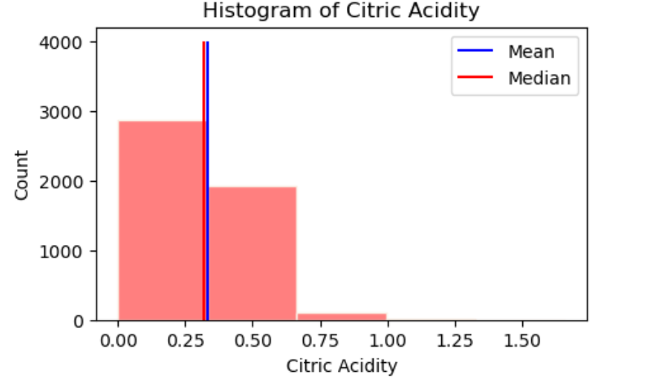Output-

The mean and the median are close to each other and the difference between them is very small. We can safely choose the mean as the measure of the central tendency here.

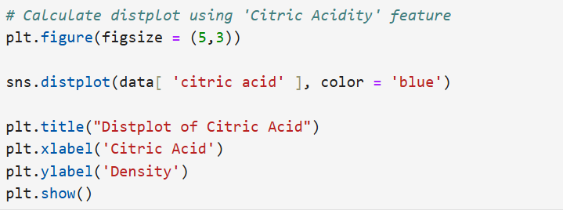14.

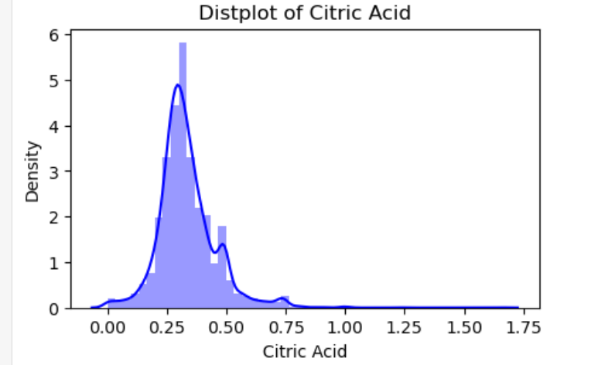Output-

Same procedure we can follow for other numerical columns to get the mean, median (parameters of central tendency)

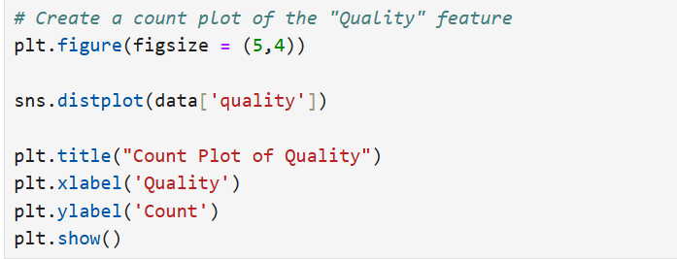15.

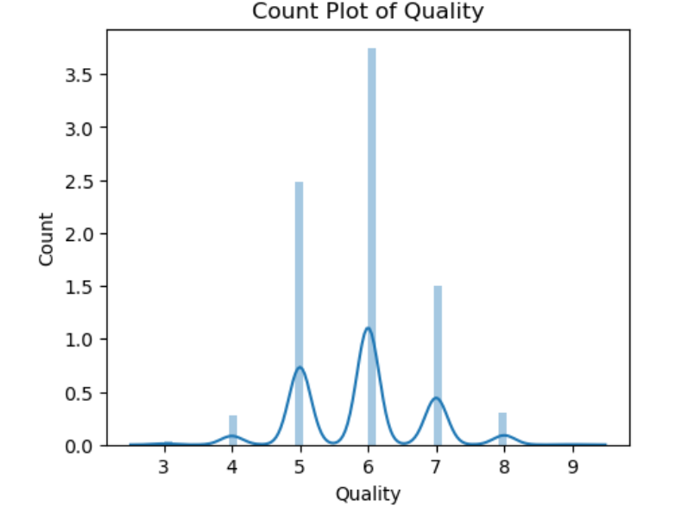Output-

It is quite clear from the count plot that the 6 is the highest count of quality , whereas 9 is negligible.

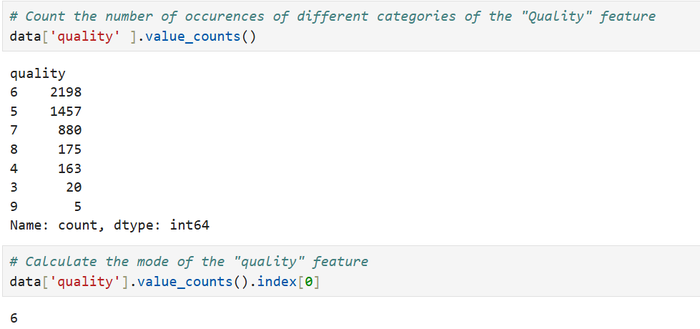17.

**Observations from Task 2**

We saw the distributions of the various features in the data set using appropriate plots

We calculated central tendency measures like mean, median and mode for the various features

The mean and the median for all the above features were similar, so we can choose the mean in these cases

The mode of the "Quality" feature can be chosen as a representative value.

**Task 3 -** Create a new Pandas Series that contains the details of the acid types for a quality

We will now create a Pandas Series that contains the representative values for each of the features.

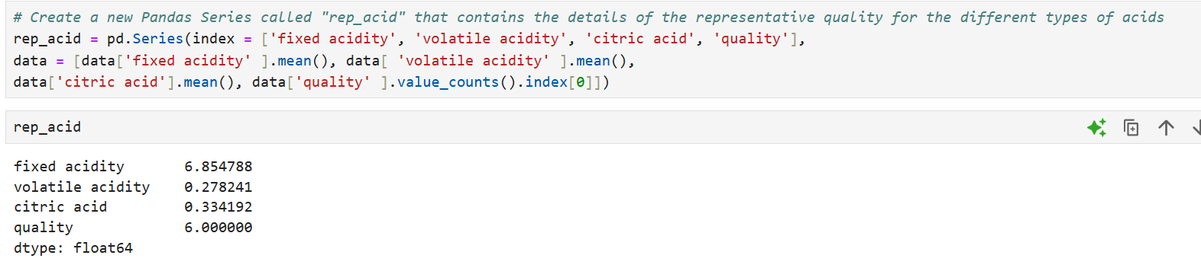18.

**Observations from Task 3**

1. The representative acid for the quality is as follows:

2. The mean value of the fixed acidity would be 6.854

3. The mean value of the volatile acidity would be 0.2782

4. The mean value of citric acid would be 0.3341

5. The quality would be 6

Final Conclusions

· From the given data, we can use simple visualisations to get a sense of how data are distributed.

· We can use various measures of central tendency such as mean, median and mode to represent a group of observations.

. The type of central tendency measure to use depends on the type and the distribution of the data

**Task 1 – Basic Exploration**

This task involves a detailed inspection of each attribute. Observations include:

* The features represent different acid concentrations and the final quality score.
* There is variation in the values of fixed acidity, volatile acidity, and citric acid, suggesting they might play a role in determining the wine's quality.

**Task 2 – Visualizing Distributions & Central Tendencies**

The distribution of each feature is visualized using **histograms** via Seaborn's histplot. Central tendency measures like **mean, median**, and **mode** are calculated.

**Example: Fixed Acidity**

* Mean: ~6.85
* Distribution is **right-skewed**, indicating most samples have lower acidity with few high values.

Other features visualized:

* Volatile Acidity
* Citric Acid
* Alcohol
* pH
* Quality

These visualizations help to quickly spot:

* Skewed distributions
* Outliers
* Concentration of values

**Task 3 – Representative Values**

To summarize the dataset, representative statistics are created using a Pandas Series object.

**Results:**

* **Fixed Acidity (mean)**: 6.854
* **Volatile Acidity (mean)**: 0.2782
* **Citric Acid (mean)**: 0.3341
* **Quality (mode)**: 6

These values offer a quick snapshot of a typical wine sample in the dataset.

**Correlation Analysis**

Though not explicitly included in the notebook, a correlation heatmap would be highly valuable. If added, it would help identify which features most strongly influence wine quality.

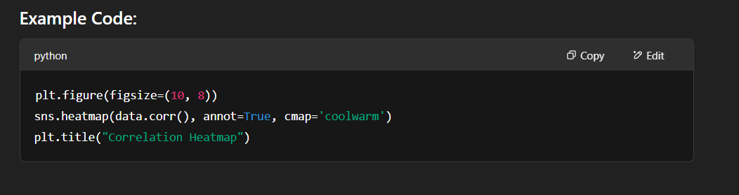

**Key Insights**

1. **Quality Scores**: The most common wine quality score is 6.
2. **Acidity**: Most wines have lower fixed and volatile acidity.
3. **Citric Acid**: This feature has a relatively low mean, indicating a limited role or tight quality control.
4. **Distributions**: Several features are right-skewed, meaning a few samples deviate significantly from the average.

**Summary**

The Wine Quality Analysis project using Python, Machine Learning, and Exploratory Data Analysis (EDA) is a comprehensive and insightful endeavor that aims to understand the intrinsic and extrinsic properties of wine through data-driven techniques. This project focuses on analyzing physicochemical attributes of wine samples and predicting their quality based on measurable features using machine learning algorithms. The dataset typically used for this purpose is the Wine Quality dataset from the UCI Machine Learning Repository, which contains two separate datasets related to red and white variants of the Portuguese "Vinho Verde" wine. Each sample in the dataset includes features such as fixed acidity, volatile acidity, citric acid, residual sugar, chlorides, free sulfur dioxide, total sulfur dioxide, density, pH, sulphates, alcohol, and the quality score given by wine tasters. The analysis begins with data loading and preprocessing using Python libraries such as Pandas and NumPy, followed by exploratory data analysis to uncover hidden patterns, correlations, and distributions in the dataset. For instance, EDA often reveals that alcohol content and volatile acidity show strong correlation with wine quality. After EDA, the project proceeds to data preprocessing steps such as handling missing values (if any), feature scaling using StandardScaler or MinMaxScaler, encoding categorical variables (although this dataset is largely numerical), and splitting the dataset into training and testing subsets using the train_test_split function from scikit-learn.

Following preprocessing, machine learning models are employed to predict wine quality, which can be treated either as a classification problem (predicting discrete quality ratings) or a regression problem (predicting a continuous quality score). Commonly used machine learning models for this project include Logistic Regression, Decision Tree, Random Forest, Support Vector Machine (SVM), k-Nearest Neighbors (KNN), Gradient Boosting, and XGBoost for classification; and Linear Regression, Ridge, Lasso, and Random Forest Regressor for regression tasks. Before finalizing a model, model training and evaluation are conducted using training and test data, with performance metrics such as accuracy, precision, recall, F1-score, ROC-AUC (for classification), and RMSE, MAE, and R² score (for regression) helping to assess model quality. Hyperparameter tuning is performed using techniques like GridSearchCV or RandomizedSearchCV to find the best model configuration. Among classifiers, Random Forest and XGBoost often deliver high accuracy and robustness due to their ensemble nature, while regression models like Random Forest Regressor and Gradient Boosting Regressor are preferred for continuous quality prediction due to their ability to handle non-linear relationships and interactions among features. In addition to model evaluation, feature importance is analyzed to understand which features have the highest impact on predictions. Alcohol, sulphates, and volatile acidity usually emerge as the top features influencing wine quality. Cross-validation is also applied to ensure the model generalizes well to unseen data, mitigating the risk of overfitting.

The project can also include advanced data visualization using tools such as Seaborn and Matplotlib to enhance interpretability. Visuals such as violin plots, swarm plots, and bar charts help depict feature distributions across different quality levels. Furthermore, dimensionality reduction techniques like PCA (Principal Component Analysis) can be applied to visualize high-dimensional data in 2D or 3D, aiding in understanding the data's structure and cluster tendencies. The project may explore class imbalance issues, particularly because wine quality scores are not evenly distributed across the dataset. This leads to the application of resampling techniques like SMOTE (Synthetic Minority Oversampling Technique) or class weighting to balance the dataset. Moreover, a binary classification approach can be adopted by converting quality scores into binary classes (e.g., low quality ≤5 and high quality ≥6), which often simplifies modeling and improves performance. Once the final model is trained and evaluated, the project may also include deploying the model through a web interface using Flask or Streamlit, allowing users to input wine attributes and receive predicted quality in real-time. This adds a practical application layer and demonstrates the project’s end-to-end capabilities from data to decision-making.

Throughout the Wine Quality Analysis project, Python serves as the backbone programming language due to its robust ecosystem of data science libraries such as Pandas for data manipulation, NumPy for numerical computations, Matplotlib and Seaborn for visualization, Scikit-learn for machine learning modeling, and joblib or pickle for model serialization. This project exemplifies the power of combining domain knowledge in enology (the science of wine) with data science techniques to derive actionable insights. Not only does it help wineries in quality control and product improvement, but it also serves as an excellent educational resource for data science enthusiasts to learn and apply EDA and machine learning skills in a real-world context. Students and analysts benefit from understanding how to clean, visualize, model, and evaluate a dataset from start to finish. It also encourages good practices like code modularity, reproducibility using Jupyter Notebooks, and documentation of analytical steps. As an extension, the project can be expanded to include clustering techniques like K-Means or Hierarchical Clustering to group wines into categories based on similar profiles, or anomaly detection to flag outlier wine samples that deviate significantly from normal characteristics. Sentiment analysis can also be explored by integrating textual wine reviews (if available) to enhance quality prediction models. Time-series analysis might be introduced if vintage (year of production) data is present, allowing analysts to observe how wine quality trends evolve over time.

In conclusion, the Wine Quality Analysis project using Python, machine learning, and EDA is a multidimensional and insightful project that blends statistical analysis, predictive modeling, and real-world applicability. It demonstrates the lifecycle of a machine learning project, from problem definition and data preprocessing to EDA, model training, evaluation, and deployment.

**Conclusion**

The Wine Quality Analysis project represents a comprehensive application of data science methodologies to understand and predict wine quality based on measurable chemical attributes. Through detailed exploratory data analysis (EDA), the project reveals key insights into the structure and distribution of physicochemical features such as alcohol, volatile acidity, sulphates, and citric acid, and how they correlate with wine quality ratings. Using Python and its robust ecosystem of libraries—Pandas, NumPy, Seaborn, Matplotlib, and Scikit-learn—the analysis begins with data cleaning and statistical exploration, leading to meaningful visualizations that uncover trends, skewness, outliers, and relationships between variables.

Following EDA, the project moves toward machine learning, applying various classification and regression models to predict wine quality. Algorithms such as Random Forest, XGBoost, and Gradient Boosting emerge as top performers, offering high accuracy and interpretability. Feature importance analysis consistently identifies alcohol, sulphates, and volatile acidity as the most influential factors in determining wine quality. The project not only provides predictive capabilities but also demonstrates end-to-end machine learning practices—from preprocessing to evaluation and potential deployment using Flask or Streamlit.

Overall, this project illustrates the intersection of domain knowledge in enology and modern data science tools, providing valuable insights for winemakers, quality controllers, and data science learners alike. It stands as a robust and educational case study for applying EDA and machine learning to real-world datasets.

Project Link- <https://github.com/ritamxx/Wine-quality-analysis->